 | Cambridge Mathematics Stage 2  Name: ………………………………………………….  Class: …………… Date: ……………………… /42
Week 5 Homework - Unit 5: Working with numbers to 100
- Sort the numbers in the box (even or odd):
11 | 4 | 10 | 23 | 36 | 49 | 50 | 55 | 78 | 87

Even numbers | Odd numbers
 | 11,
/9
- Look at the blocks. Write the equation:
0. |   + | ___9__ + __3___ = ___12__
1. | + | _____ + _____ = _____
2. | + | _____ + _____ = _____
3. | + | _____ + _____ = _____
4. | + | _____ + _____ = _____
5. | + | _____ + _____ = _____
/5
- Write the missing numbers:
3.1 Count on in 2s:
2 | 4 |  |  | 10 |  | 14 |  | 18
/5
3.2 Count on in 2s:
50 | 52 | 54 |  |  |  | 62 | 64
/5
3.3 Count on in 5s:
30 | 35 |  |  | 50 |  | 60 |  | 70
/5
3.4 Count on in 5s:
5 |  | 15 |  | 25 | 30 |  |  |  | 50
/5
3.5 Count on in 10s:
10 | 20 | 30 |  |  | 60 |  |  |  | 100
/5

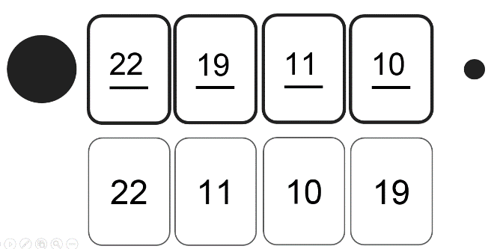
- Order the numbers from biggest to smallest:
0. |  | 1. | 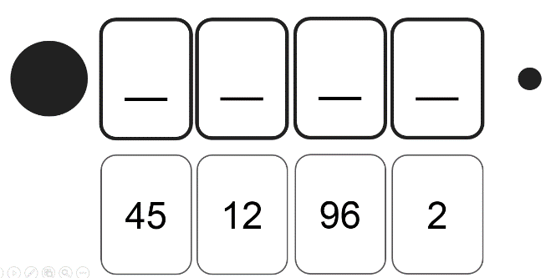
2. | 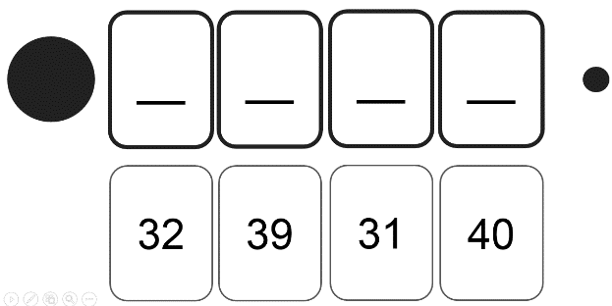 | 3. | 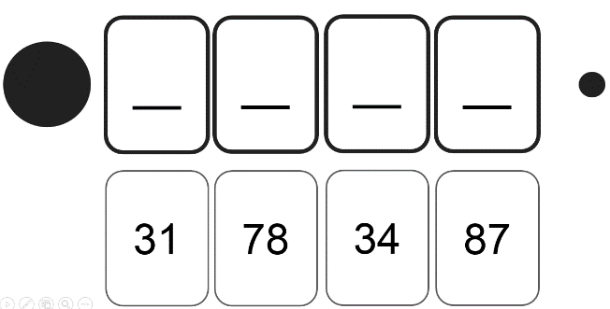
/3

